**PIZZA SALES SQL QUERIES**

**Total Revenue:**

select sum(total_price) as total_revenue from pizza_sales

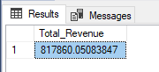

**Average order value:**

select sum(total_price)/sum(quantity) as average_order_value from pizza_sales

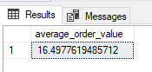

**Total pizza sold**

select sum(quantity) as total_pizza_sold from pizza_sales

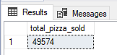

**average pizza per order**

Select CAST(CAST(SUM(quantity) AS DECIMAL(10,2)) /

CAST(COUNT(DISTINCT order_id) AS DECIMAL(10,2)) AS DECIMAL(10,2))

AS Avg_Pizzas_per_order

FROM pizza_sales

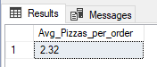

**Daily Trends for total orders**

select datename(dw, order_date) as day,count(distinct order_id) as total_order from pizza_sales

group by datename(dw, order_date)

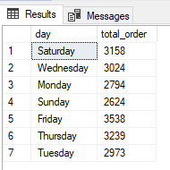

**Hourly Trends for total orders**

select datepart(hour,order_time) as hour,count(distinct order_id) as total_order from pizza_sales

group by datepart(hour,order_time)

order by datepart(hour,order_time)

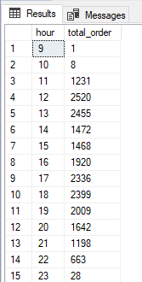

**percentage of sales by pizza category**

select pizza_category,sum(total_price) as revenue,

round(sum(total_price)/(select sum(total_price) from pizza_sales)*100,2) as percentage_sale_by_catogary

from pizza_sales

group by pizza_category

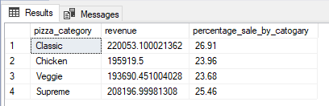

**percentage of sales by pizza size**

select pizza_size,round(sum(total_price),2) as revenue,

round(sum(total_price)/(select sum(total_price) from pizza_sales)*100,2) as percentage_sale_by_catogary

from pizza_sales

group by pizza_size

